Project Design Phase-II
Technology Stack (Architecture & Stack)

Date | 6 Febuary 2026
Team ID | LTVIP2026TMIDS64619
Project Name | Advancing nutrition science through geminiai
Maximum Marks | 4 Marks

Technical Architecture:
The Deliverable shall include the architectural diagram as below and the information as per the table1 & table 2
Example: Order processing during pandemics for offline mode
Reference: https://developer.ibm.com/patterns/ai-powered-backend-system-for-order-processing-during-pandemics/

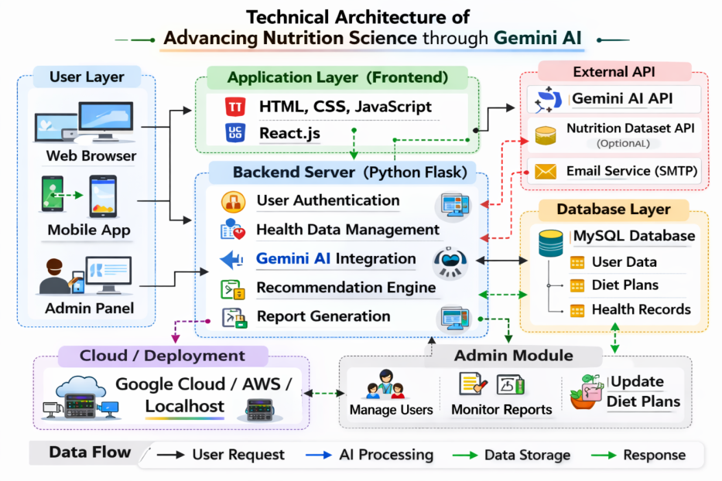

Table-1 : Components & Technologies:

S.No | Component | Description | Technology
 | User Interface | How user interacts with application e.g.  Web UI, Mobile App, Chatbot etc. | HTML, CSS, JavaScript
 | Application Logic-1 | Logic for a process in the application | Python(flask)
 | Application Logic-2 | Logic for a process in the application | Gemini AI API
 | Application Logic-3 | Logic for a process in the application | Machine Learning (scikit-learn)
 | Database | Data Type, Configurations etc. | MySQL/SQLite
 | Cloud Database | Database Service on Cloud | Google Firebase.
 | File Storage | File storage requirements | Local Filesystem
 | External API-1 | Purpose of External API used in the application | Gemini AI API
 | External API-2 | Purpose of External API used in the application | Not Applicable.
 | Machine Learning Model | Purpose of Machine Learning Model | Nutrition Recommendation Model
 | Infrastructure (Server / Cloud) | Application Deployment on Local System / Cloud  Local Server Configuration:  Cloud Server Configuration : | Google cloud.

Table-2: Application Characteristics:
S.No | Characteristics | Description | Technology
 | Open-Source Frameworks | List the open-source frameworks used | Flask. Pandas, Numpy
 | Security Implementations | List all the security / access controls implemented, use of firewalls etc. | Authentication, Encryption
 | Scalable Architecture | Justify the scalability of architecture (3 – tier, Micro-services) | Local host/cloud
 | Availability | Justify the availability of application (e.g. use of load balancers, distributed servers etc.) | Clean code, documentation
 | Performance | Design consideration for the performance of the application (number of requests per sec, use of Cache, use of CDN’s) etc. | Secure authentication.

References:
https://c4model.com/
https://developer.ibm.com/patterns/online-order-processing-system-during-pandemic/
https://www.ibm.com/cloud/architecture
https://aws.amazon.com/architecture
https://medium.com/the-internal-startup/how-to-draw-useful-technical-architecture-diagrams-2d20c9fda90d

